B. Tech Seminar Report on

NON-INVASIVE BRAIN

COMPUTER INTERFACES
Submitted in partial fulfillment for the award of the Degree of Bachelor of Technology in Computer Science & Engineering

Submitted by

ASNA AZAD
(Reg.No: MEK22CS015)

Under the guidance of

Prof. SAJINSHA.N



Department of Computer Science & Engineering
MES Institute of Technology and Management, Chathannoor, Kollam

August 2025

DEPARTMENT OF COMPUTER SCIENCE & ENGINEERING MES INSTITUTE OF TECHNOLOGY AND MANAGEMENT, KOLLAM



CERTIFICATE

Certified that this report entitled ‘NON-INVASIVE BRAIN COMPUTER INTERFACES’ is a Bonafide record of the seminar done by ASNA AZAD (MEK22CS015) in partial fulfillment for the award of the Degree of Bachelor of Technology in Computer Science & Engineering from the APJ Abdul Kalam Technological University for the year 2025.

Prof. Sajinsha.N
Assistant Professor
(Guide)
Dept. of CSE(AI)
Prof. Shibinisha Shahul Assistant Professor
(Seminar Co-Ordinator) Dept. of CSE

Prof. Saheer H Associate Professor & HoD
Dept. of CSE

Place:
Date:

First and foremost, I wish to place on records my ardent and earnest gratitude to my seminar guide Prof.Sajinsha.N, Assistant Professor, Dept. of Computer Science and Engineering (AI). His tutelage and guidance was the leading factor in translating my efforts to fruition. His prudent and perceptive vision has shown light on my trail to triumph.

I would like to express my sincere thanks to our respected Principal in charge
Prof.RAFI A for the facilities provided for presenting this seminar.

I am extremely happy to mention a great word of gratitude to Prof. SAHEER H., Head of the Department of Computer Science and Engineering for providing me with all facilities for the completion of this work.

Finally yet importantly, I would like to express my gratitude to my Seminar Coordinator Prof.Shibinisha Shahul, Assistant Professor, Dept. of Computer Science and Engineering for her valuable assistance provided during the course of the seminar.

I also extend my gratefulness to all the staff members in the Department. I also thank all my friends and well-wishers who greatly helped me in my endeavour.

ASNA AZAD

Brain–Computer Interfaces (BCIs) are technologies that enable direct communication between the human brain and external devices, without the involvement of muscles or speech. Non-invasive BCIs, which use external sensors such as electroencephalography (EEG) to detect brain activity, have become popular because they are safe, painless, and more accessible compared to invasive methods. This seminar reviewed the latest developments in non-invasive BCI systems with the aim of understanding their capabilities, challenges, and potential applications. The review was based on recent peer-reviewed research papers, IEEE conference publications, and technical reports from the last five years. The study examined improvements in brain signal acquisition, feature extraction, and classification methods, along with their impact on system accuracy, speed, and user comfort. Findings showed that the use of advanced machine learning techniques, better signal processing methods, and modern wearable EEG devices has led to significant progress in accuracy and usability. These systems have been successfully applied in assistive technologies, neurorehabilitation, and human–computer interaction, helping people with severe physical disabilities to communicate and control devices. However, limitations such as noise interference, variable performance in real-world conditions, and low information transfer rates remain. The seminar concluded that future work should focus on hybrid BCIs, AI-powered adaptive systems, and integration with virtual or augmented reality to improve performance and broaden accessibility. This study was primarily based on the IEEE publication “Non-Invasive Brain–Computer Interfaces: State of the Art and Trends” by Edelman. (2025).

 |  |  |  |  |  |  |  |  |  |  |  |  |  |  |  |  |  |  |  |  | CONTENTS
Chapter No |  | Title | Page No
 |  | List of Abbreviation | iii
 |  | List of Figures | iv
1 |  | Introduction | 1
2 |  | Literature Review | 3
3 |  | BCI Framework & Signal Acquisition | 6
 | 3.1 | System Overview | 7
 | 3.2 | Signal Acquisition Modalities | 7
 | 3.3 | Feature Extraction And Decoding | 8
 | 3.4 | Feedback And Adaptation | 9
4 |  | Difference between Invasive And Non-Invasive BCIs | 10
 | 4.1 | Introduction | 10
 | 4.2 | Invasive BCI Overview | 10
 | 4.3 | Non-Invasive BCI Overview | 10
 | 4.4 | Comparative Analysis | 11
5 |  | Non-Invasive Techniques & Signals | 13
 | 5.1 | Non-Invasive Recording Methods | 13
 | 5.2 | Major Non-Invasive Signal Types | 14
 | 5.3 | Advantages And Limitations | 16

6 |  | Algorithm And Toolboxes | 18
 | 6.1 | Signal Preprocessing | 18
 | 6.2 | Feature Extraction | 18
 | 6.3 | Decoding Algorithms | 19
 | 6.4 | BCI Toolboxes And Software platform | 19
7 |  | Applications Of BCI | 21
 | 7.1 | Clinical Rehabilitation Applications | 21
 | 7.2 | Assistive Device Control | 22
 | 7.3 | Consumer And Entertainment users | 22
 | 7.4 | Research And Industrial Applications | 22
 | 7.5 | Representative Cases Studies | 23
8 |  | Challenges & Future Scope | 25
 | 8.2 | Human And Ethical Considerations | 26
 | 8.3 | Future Research Directions | 26
9 |  | User Training Strategies In Non-Invasive BCIs | 28
 | 9.1 | Overview And Importance | 28
 | 9.2 | Training Procedures And Feedback | 28
 | 9.3 | Research Outcomes And Future Directions | 29
10 |  | Conclusion | 31
 |  | References | 32

LIST OF ABBREVIATIONS

BCI - Brain–Computer Interface
EEG - Electroencephalography
ECoG - Electrocorticography
MEG - Magnetoencephalography
fNIRS - Functional Near-Infrared Spectroscopy
CSP - Common Spatial Patterns
VR - Virtual Reality
AR - Augmented Reality

LIST OF FIGURES

Figure No Title Page No
3.1 | BCI Framework | 6
5.1 | Comparison diagram of invasive vs. non-invasive signal acquisition | 14
5.2 | Signal acquisition and pre-processing pipeline | 16
8.1 | pplications of non-invasive BCIs | 24

CHAPTER 1

INTRODUCTION

The human brain is the most complex organ in the body, capable of generating electrical signals that control thoughts, movements, and communication. Traditionally, interaction with machines has required physical actions such as typing on a keyboard, speaking into a microphone, or using gestures. However, for patients suffering from neuromuscular disorders such as Amyotrophic Lateral Sclerosis (ALS), spinal cord injury, or stroke, the ability to control muscles and perform these actions is severely impaired. In such cases, Brain–Computer Interfaces (BCIs) provide a revolutionary alternative by bypassing the traditional neuromuscular pathways and directly translating brain activity into commands that can control external devices. This enables individuals to regain communication, mobility, and independence, while also opening new frontiers in human–machine interaction.

A Brain–Computer Interface is essentially a system that acquires brain signals, processes them, and converts them into outputs that can replace, restore, or augment natural neural functions. BCIs can be classified into invasive and non-invasive categories. Invasive BCIs involve implanting electrodes directly into brain tissue, which allows high-quality signal acquisition but comes with significant medical risks. Non-invasive BCIs, on the other hand, use external methods such as electroencephalography (EEG) to capture signals. These are safer, more portable, and more accessible, although they have lower resolution compared to invasive methods. Despite these limitations, non-invasive BCIs are the most widely researched and deployed due to their practicality and affordability.

The development of BCIs can be traced back to the 1970s, when early experiments using EEG demonstrated the feasibility of direct communication between the brain and external systems. Initial applications were limited to simple yes/no communication or basic cursor control. In the 1990s and early 2000s, systems such as P300 spellers and Steady-State

Visual Evoked Potentials (SSVEP) expanded the possibilities for communication. In recent years, the integration of machine learning, deep learning, and advanced neuroimaging has led to BCIs capable of controlling robotic arms, wheelchairs, drones, and even smart homes. The focus has increasingly shifted towards non-invasive BCIs, which combine safety with growing sophistication in hardware and algorithms.

The importance of non-invasive BCIs lies not only in their medical value but also in their broader applications across society. In healthcare, they assist patients with motor disabilities by restoring lost communication and mobility. In education, they can monitor attention levels in classrooms, while in entertainment, they provide brain-controlled gaming and immersive virtual reality experiences. In industry, BCIs are being explored for applications such as fatigue detection in drivers and machine operators, while in defense they hold potential for secure communication and drone control. This wide scope highlights the transformative nature of BCI technology beyond healthcare.

Despite remarkable progress, several challenges remain. Non-invasive BCIs still suffer from a low signal-to-noise ratio, meaning that brain activity is often masked by unwanted artifacts and noise. Many users also struggle with what is known as “BCI illiteracy,” where they find it difficult to produce reliable signals for control. Long-term usage can cause fatigue, and ethical concerns surrounding neural data privacy and security are also growing. Nevertheless, with the development of consumer-grade EEG headsets such as Emotiv, OpenBCI, and Muse, combined with rapid advances in artificial intelligence, non-invasive BCIs are expected to become more reliable, user-friendly, and widely available. These systems are steadily moving out of laboratories and into everyday life, making them one of the most promising technologies for the future of human–machine interaction.

CHAPTER 2
LITERATURE REVIEW

Research in Brain–Computer Interfaces (BCIs) has evolved over more than five decades, moving from simple proof-of-concept experiments to sophisticated non-invasive systems capable of real-time control. This chapter surveys key milestones and representative studies that laid the foundation for present-day non-invasive BCIs.

Early Developments

Initial work in the 1970s and 1980s focused on demonstrating that electrical activity recorded from the scalp could be used for basic communication. Experiments using electroencephalography (EEG) enabled simple yes/no responses and elementary cursor control tasks. These pioneering studies proved that the human brain could directly interface with a computer without muscular activity.

Advance In Signal Paradigms

Progress accelerated with the discovery of event-related potentials and oscillatory phenomena that could be reliably detected in EEG signals.

- P300 spellers introduced in the late 1980s enabled users to select letters from a matrix by evoking a P300 response to infrequent visual “oddball” stimuli, dramatically improving communication speed and accuracy.

- Steady-State Visual Evoked Potentials (SSVEPs) offered high information-transfer rates by exploiting frequency-specific brain responses to flickering visual targets.
- Motor Imagery (MI) paradigms used event-related (de)synchronization in the sensorimotor cortex to control cursors and robotic devices without external stimuli, paving the way for rehabilitation applications

Hybrid And Multimodel BCIs

More recent investigations explore hybrid BCIs, which combine multiple signals (e.g., SSVEP with MI or P300) to enhance robustness and control dimensionality. Magnetoencephalography (MEG) and functional near-infrared spectroscopy (fNIRS) have been integrated with EEG to provide complementary spatial or hemodynamic information, albeit with greater hardware complexity.

Algorithmic Breakthroughs

Parallel progress in machine learning and signal processing has transformed BCI decoding. Early approaches relied on linear discriminant analysis and common spatial patterns, while modern systems increasingly employ deep learning architectures—CNNs, RNNs, and transformers—to automatically extract spatial-temporal features and enable calibration-free operation. Transfer learning and domain adaptation further improve generalization across users and sessions

Open-Source Toolboxes and Standardization

Community-driven platforms such as BCI2000, OpenViBE, EEGLAB, and MNE-Python have standardized experimental design, improved reproducibility, and lowered the barrier for large-scale studies. These resources accelerate innovation by allowing researchers and developers to build upon common frameworks

Clinical and Consumer Applications
Non-invasive BCIs have demonstrated success in clinical contexts such as communication for patients with amyotrophic lateral sclerosis (ALS), neurorehabilitation after stroke, and mobility restoration for individuals with spinal cord injuries. Outside healthcare, BCIs have entered consumer domains including gaming, virtual/augmented reality, and smart-home control

Summary
The literature shows a clear trajectory: from basic EEG-based communication to sophisticated, AI-enhanced systems capable of complex control. This evolution reflects parallel advances in neuroscience, sensor technology, and computational methods, establishing a robust foundation for the continued expansion of non-invasive BCI research and its translation into everyday applications.

CHAPTER 3

BCI FRAMEWORK & SIGNAL ACQUISITION

A Brain–Computer Interface (BCI) system transforms neural activity into commands that can operate external devices. Regardless of application, most non-invasive BCIs follow a similar end-to-end framework consisting of five key stages: signal acquisition, preprocessing, feature extraction, decoding, and device control with feedback.

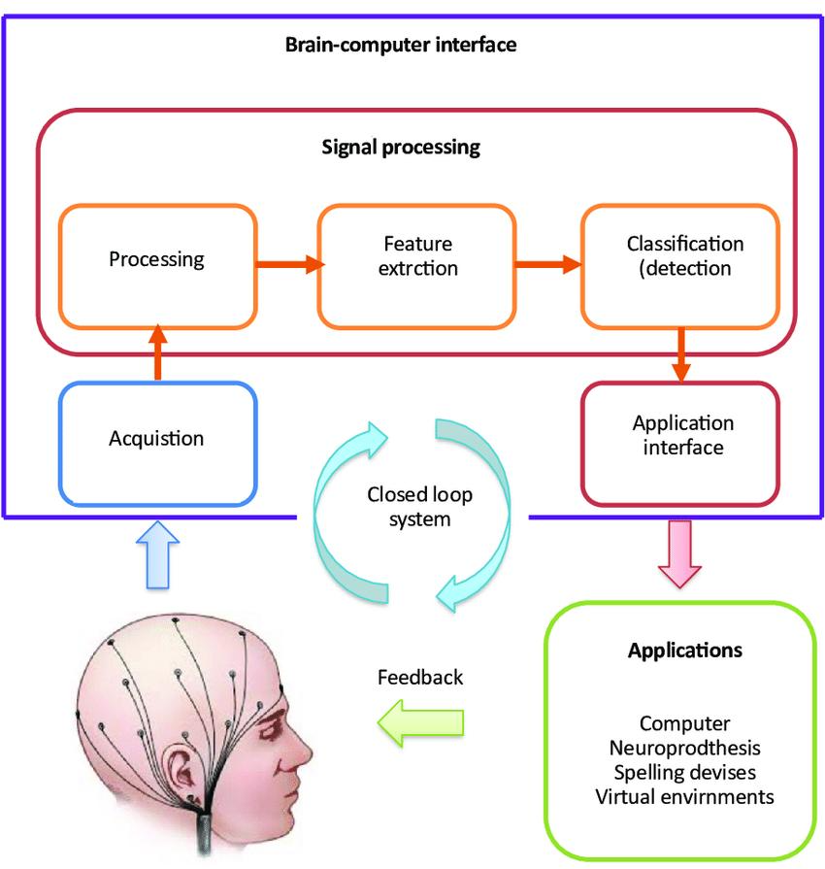

Figure 3.1: General framework of a non-invasive Brain–Computer
Interface showing the main pipeline from signal acquisition
through device control and feedback.

3.1 System Overview
The fundamental BCI loop begins with brain signal acquisition, proceeds through digital processing, and culminates in real-time feedback to the user:

- Signal Acquisition – Captures electrical or hemodynamic activity using non-invasive sensors such as EEG electrodes, magnetoencephalography (MEG) coils, or functional near-infrared spectroscopy (fNIRS) probes.

- Preprocessing & Artifact Removal – Filters noise and physiological artifacts (e.g., eye blinks, muscle activity) through band-pass filtering, independent component analysis, or adaptive filtering.

- Feature Extraction – Translates raw signals into informative representations in time, frequency, or spatial domains.

- Decoding Algorithms – Machine learning models—ranging from classic linear discriminant analysis to modern deep learning—classify the extracted features and determine user intent.

- Device Control & Feedback – Commands drive external devices such as cursors, wheelchairs, robotic arms, or virtual-reality objects. Feedback allows users to adapt their mental strategies, improving performance over time.

3.2 Signal Acquisition Modalities

While several non-invasive techniques exist, electroencephalography (EEG) remains the gold standard for practical BCI applications because of its high temporal resolution, portability, and low cost. Other modalities offer complementary strengths:

- EEG – Records scalp electrical potentials with millisecond precision. Wireless and dry-electrode systems now allow up to 128 channels and >2 kHz sampling rates, suitable for mobile use.

- MEG – Detects magnetic fields generated by neuronal currents, providing excellent temporal and good spatial resolution but requiring shielded rooms and costly equipment.

- fNIRS – Measures hemodynamic responses linked to neural activity; though slower (∼1–2 s resolution), it is portable and can be combined with EEG for hybrid BCIs.

Key design goals during acquisition include maximizing signal-to-noise ratio (SNR) and ensuring user comfort for extended sessions.

3.3 Feature Extraction and Decoding

Effective feature extraction converts noisy neural recordings into discriminative representations. Common approaches include:
- Spectral methods to capture frequency-band power changes such as alpha (8–13 Hz) or beta (14–30 Hz).

- Spatial filters, notably Common Spatial Patterns (CSP), to highlight task-related cortical regions.
- Time-frequency analyses like wavelet transforms for transient event detection.
Recent advances leverage deep learning—convolutional neural networks (CNNs), recurrent networks (RNNs), and transformer architectures—to automatically learn complex spatial-temporal patterns and reduce the need for manual feature design.

3.4 Feedback and Adaptation
A closed feedback loop is essential for user learning. Visual cues (cursor movement, virtual limbs) or haptic signals guide the user to modulate brain activity, thereby improving accuracy and reducing “BCI illiteracy.” Adaptive algorithms that update model parameters online further enhance long-term usability.

3.5 Summary
The BCI framework integrates neuroscience, signal processing, and machine learning into a unified pipeline. Among the various signal acquisition methods, EEG dominates for non-invasive BCIs because it balances cost, resolution, and ease of deployment. Future systems aim to be fully wearable, calibration-free, and seamlessly integrated into daily life through continual improvements in sensors and AI-based decoding.

Chapter 4

DIFFERENCE BETWEEN INVASIVE

AND NON-INVASIVE BCIs

4.1 Introduction
Brain–Computer Interfaces (BCIs) create a direct communication pathway between the human brain and external devices by translating neural activity into digital signals.
BCIs are generally classified into invasive and non-invasive types based on how these signals are recorded.
Although both aim to enable seamless interaction between humans and machines, they differ fundamentally in their signal-acquisition methods, performance characteristics, safety considerations, and cost.
Understanding these distinctions is critical for choosing the appropriate technology for medical, research, or consumer applications.

4.2 Invasive BCI Overview
Invasive BCIs involve the surgical implantation of electrodes either directly into the cerebral cortex (intracortical microelectrodes) or on the cortical surface beneath the skull (electrocorticography, ECoG).
Because the electrodes interface closely with neural tissue, invasive systems capture action potentials and local field potentials with very high spatial and temporal resolution.
This precision supports fine-grained control of prosthetic limbs or computer cursors, but implantation carries significant medical risk and requires ongoing clinical oversight.

4.3 Non-Invasive BCI Overview
Non-invasive BCIs record neural activity without surgery using external sensors such as electroencephalography (EEG), magnetoencephalography (MEG), or functional near-

infrared spectroscopy (fNIRS).
Signals must pass through the skull and scalp, which reduces amplitude and spatial precision, but the approach is safe, painless, and reversible.
Lightweight EEG headsets and dry-electrode technology have further increased the practicality of non-invasive BCIs for clinical, educational, and consumer uses.

4.4 Comparative Analysis
Below is a concise, side-by-side summary of the major differences:
Aspect | Invasive BCI | Non-Invasive BCI
Signal Acquisition | Electrodes surgically implanted into or on the cortex (e.g., microelectrode arrays, ECoG). | External sensors (EEG, MEG, fNIRS) placed on the scalp.
Signal Quality | Very high spatial and temporal resolution; can detect individual neuron firing. | Lower resolution; signals attenuated by skull and scalp and more prone to noise.
Safety & Risk | Requires neurosurgery; risk of infection, bleeding, tissue reaction, and long-term maintenance issues. | Non-surgical and painless; minimal medical risk and fully reversible.
Cost & Accessibility | High cost due to surgery, hospital care, and specialized teams. | Lower cost; portable and widely accessible for clinical and consumer use.
Applications | High-precision prosthetic control, deep-brain stimulation, locked-in patient communication. | Communication aids (P300 speller), neurofeedback, gaming, VR/AR control, cognitive monitoring.
Regulatory & Ethical Issues | Requires rigorous clinical trials and ongoing ethical oversight for implants. | Fewer medical-ethics hurdles but still subject to privacy and neural-data security concerns.

4.5 Summary
Invasive BCIs deliver unparalleled signal fidelity and fine motor control but demand neurosurgical implantation, carry higher costs, and raise complex ethical questions.
Non-invasive BCIs prioritize safety, portability, and ease of deployment, making them suitable for a much wider audience despite lower signal resolution.
Both approaches complement each other in advancing the field of neurotechnology, and future hybrid systems may integrate the strengths of each to achieve both high precision and minimal risk.

CHAPTER 5

NON-INVASIVE TECHNIQUES & SIGNALS
Non-invasive Brain–Computer Interfaces (BCIs) acquire neural activity without surgical procedures, providing a safe and practical solution for both clinical and consumer use. This chapter outlines the principal non-invasive recording techniques and the major signal types used for control and communication.

5.1 Non-Invasive Recording Methods

- Electroencephalography (EEG) – Measures electrical potentials from the scalp with millisecond temporal resolution. Modern wireless or dry-electrode EEG caps are light, portable, and capable of high-density recording (up to 128 channels)
- Magnetoencephalography (MEG) – Detects the magnetic fields generated by neuronal currents. It offers high temporal resolution but requires shielded rooms and remains expensive.
- Functional Near-Infrared Spectroscopy (fNIRS) – Uses infrared light to monitor hemodynamic changes related to brain activity. Although slower (seconds of latency), it complements EEG in hybrid BCIs and is easy to wear.
Among these, EEG is the most practical for everyday applications due to its low cost, mobility, and well-established processing methods.

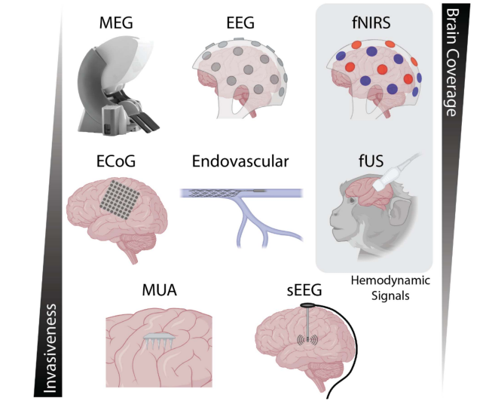
Figure 5.1: Neural recording modalities used for brain-computer interface applications. (top) Non-invasive techniques include magnetoencephalography (MEG),electroencephalography (EEG) and functional near-infrared spectroscopy (fNIRS). (middle) Minimally invasive ap
proaches involve electrocorticography (ECoG) and relatively novel technologies such as endovascular electrodes (i.e., the Stentrode) and functional ultrasound (fUS). (bottom) Invasive techniques include stereo EEG (sEEG) with penetrating electrodes and multi-unit arrays (i.e., the Utah Array). Nearly all these techniques measure electrophysiological
signals with the exception of fNIRS and fUS, which measure an indirect hemodynamic readout of neuronal activity.

5.2 Major Non-Invasive Signal Types

BCIs rely on identifiable brain patterns that can be consistently detected and decoded. Key signal categories include:

- Motor Imagery (MI) – Mental rehearsal of limb movement produces event-related desynchronization/synchronization (ERD/ERS) in the sensorimotor cortex, enabling control of cursors, wheelchairs, and robotic arms.

- Steady-State Visual Evoked Potentials (SSVEPs) – Elicited when a user focuses on a flickering visual stimulus at a known frequency, providing some of the highest information-transfer rates for spellers and selection interfaces.

- P300 Event-Related Potentials – Occur around 300 ms after a rare or “oddball” stimulus, commonly exploited for spelling devices where the desired letter is embedded in a flashing matrix.

- Slow Cortical Potentials (SCPs) & Movement-Related Cortical Potentials (MRCPs) – Low-frequency shifts time-locked to movement planning or onset, useful for initiating robotic or prosthetic actions.

- Overt Spatial Attention (OSA) – Gaze-based attention induces alpha-band changes in parietal regions, allowing multidimensional control without external stimuli.
These signals can be used individually or in hybrid BCIs, where combining multiple paradigms (e.g., MI + SSVEP) enhances robustness and control dimension.

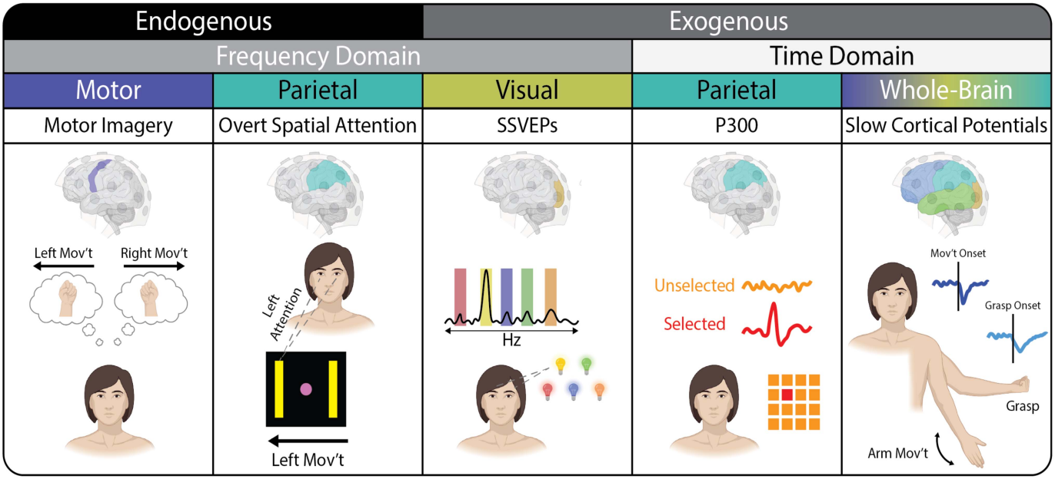

Figure 5.2:. Overview of neural signals used for noninvasive brain-computer interface control. These signals can be broadly categorized according to being endogenous or exogenous in origin, frequency or time domain, and by the brain region/electrode coverage from which they are acquired. Motor imagery tasks generate an event-related (de)synchronization that can be detected from motor electrodes and which generate a velocity-based signal for end effector control direction. Overt spatial attention refers to a gaze-based action that is detected in electrodes covering the parietal cortex and which drives an end effector in a particular direction. Steady-state visual evoked potentials (SSVEPs) refer to increases in narrow band power in electrodes covering the visual cortices upon attending to a stimulus flickering at the corresponding frequency. The P300 response is elicited during an oddball-type context when a user’s choice is selected. Finally, slow cortical potentials refer to electrical potential deflections that are time-locked to movement events or that correspond to limb kinematics.

5.3 Advantages and Limitations
Advantages
- Completely safe and painless; no surgery required.
- Suitable for repeated long-term use and large-scale studies.
- Increasingly accessible with consumer-grade EEG headsets and wireless technology.
Limitations
- Lower signal-to-noise ratio compared to invasive methods.
- Susceptible to artifacts from eye blinks, muscle movement, or environmental noise.

- Typically lower spatial resolution and information-transfer rates.
Despite these constraints, ongoing innovations in sensor design and adaptive signal processing continue to improve reliability and user comfort.

5.4 Summary

Non-invasive BCIs achieve effective brain–machine interaction by detecting specific neural signatures through safe, external sensors. EEG remains the cornerstone technology, while complementary modalities like MEG and fNIRS expand the design space. The diverse signal types—from visual evoked potentials to motor imagery—enable applications ranging from clinical rehabilitation to entertainment.

CHAPTER 6

ALGORITHMS & TOOLBOXES
Accurate decoding of brain signals is the heart of any Brain–Computer Interface (BCI). Non-invasive BCIs must extract meaningful patterns from noisy neural data and translate them into reliable commands in real time. This chapter reviews the principal signal-processing algorithms and the widely used software toolboxes that enable BCI development.

6.1 Signal Preprocessing
Before analysis, EEG and other non-invasive signals require artifact removal and filtering to improve signal-to-noise ratio:
- Band-pass filtering (e.g., 0.5–40 Hz) removes irrelevant frequency components.
- Notch filtering eliminates power-line noise.
- Independent Component Analysis (ICA) separates and suppresses artifacts such as eye blinks or muscle movements.
Effective preprocessing is crucial for minimizing false classifications and ensuring real-time performance.

6.2 Feature Extraction
Feature extraction converts continuous neural signals into discriminative representations:
- Time-domain features: amplitude, latency, and event-related potentials (ERP).
- Frequency-domain features: band power in alpha, beta, or gamma ranges for motor imagery and ERD/ERS tasks.
- Spatial filtering: Common Spatial Patterns (CSP) to highlight task-specific cortical activity.

- Time–frequency transforms: wavelet and short-time Fourier transforms for transient events.
These features form the input to machine learning classifiers.

6.3 Decoding Algorithms
Traditional Machine Learning
Classifiers such as Linear Discriminant Analysis (LDA), Support Vector Machines (SVM), and k-Nearest Neighbors (kNN) have long been used for BCI tasks due to their simplicity and robustness. These methods remain popular for applications where training data is limited or real-time operation is critical.
Deep Learning and Advanced Approaches
Recent breakthroughs employ Convolutional Neural Networks (CNNs), Recurrent Neural Networks (RNNs/LSTMs), and Transformers to automatically learn spatial-temporal EEG patterns.
- CNNs excel at extracting spatial–spectral features.
- RNNs capture temporal dependencies, improving continuous control.
- Transformers use attention mechanisms for high accuracy in complex tasks.
Additional innovations include transfer learning, domain adaptation, and generative adversarial networks (GANs) for data augmentation, all aimed at calibration-free, user-independent BCIs.

6.4 BCI Toolboxes and Software Platforms
Open-source toolboxes foster reproducibility, rapid prototyping, and collaboration:
- BCI2000 – A modular, standardized platform for real-time BCI experimentation and clinical applications.

- OpenViBE – Supports real-time acquisition, processing, and feedback with an intuitive graphical interface.
- EEGLAB – MATLAB-based environment for advanced EEG preprocessing and analysis.
- MNE-Python – Comprehensive Python suite for EEG/MEG analysis and source localization.
- FieldTrip – Provides advanced time–frequency analysis and connectivity tools.
These platforms lower development barriers and are widely adopted across academic and industrial research.

6.5 Summary
Signal-processing algorithms form the backbone of non-invasive BCIs, evolving from classic statistical classifiers to sophisticated deep-learning frameworks. Open-source software ecosystems such as BCI2000, OpenViBE, EEGLAB, and MNE-Python have accelerated innovation, enabling researchers to build reliable, real-time systems that move beyond laboratory settings toward practical clinical and consumer applications.

CHAPTER 7

APPLICATIONS OF BCI
Non-invasive Brain–Computer Interfaces (BCIs) have matured from laboratory demonstrations to practical solutions in healthcare, assistive technology, and consumer markets. This chapter highlights key application domains and representative case studies that illustrate the versatility and impact of non-invasive BCIs.

7.1 Clinical and Rehabilitation Applications

Communication for Locked-In Patients
Individuals with amyotrophic lateral sclerosis (ALS), spinal cord injury (SCI), or brainstem stroke often retain cognitive function but lose voluntary motor control. P300- or SSVEP-based spelling systems allow these patients to select letters or words on a screen by simply focusing attention, restoring basic communication capabilities.
Motor Restoration and Neurorehabilitation
Motor imagery (MI) BCIs combined with robotic exoskeletons or functional electrical stimulation can promote neuroplasticity and aid stroke recovery. Studies show improvements in motor function when patients engage in MI-driven rehabilitation sessions, especially when paired with virtual reality for immersive feedback.
Mental-Health Monitoring
EEG-based BCIs are being tested for real-time detection of stress, anxiety, and depression through analysis of oscillatory patterns. Neurofeedback training using these signals shows promise for regulating mood and cognitive states.

7.2 Assistive Device Control
BCIs enable individuals with severe mobility impairments to interact with their environment:
- Wheelchair Navigation – P300 or MI protocols can drive powered wheelchairs through complex paths, giving users autonomous mobility in daily settings.

- Robotic Arm Control – EEG-based decoding of motor imagery supports multi-dimensional reach-and-grasp tasks, as demonstrated in studies where subjects successfully controlled robotic arms to pick and place objects with over 80 % accuracy.

- Smart-Home Integration – BCI commands can operate lights, fans, and IoT devices, promoting independence for people with disabilities.

7.3 Consumer and Entertainment Uses
Outside clinical care, BCIs are finding traction in gaming, virtual reality (VR), and augmented reality (AR). EEG headsets allow players to move objects or navigate virtual worlds using thought patterns, creating immersive experiences. Educational tools use attention-monitoring BCIs to adapt content dynamically for improved learning

7.4 Research and Industrial Applications
- Driver Drowsiness Detection – BCIs embedded in automotive systems can monitor fatigue and alert drivers.

- Defense and Security – Experimental BCIs have been tested for secure communication and drone navigation.

- Human–Machine Augmentation – Research explores BCI-driven exoskeletons and collaborative robots to enhance human capabilities in industrial environments.

7.5 Representative Case Studies
- EEG-Controlled Drone Flight – Experiments combining MI and SSVEP tasks have demonstrated three-dimensional control of quadcopters, proving the feasibility of continuous BCI-based navigation.

- Hybrid BCI for Robotic Grasping – Integrating motor imagery with real-time electrical source imaging achieved continuous reach and grasp of a robotic arm with improved accuracy.

- VR-Based Stroke Therapy – Patients using MI tasks in immersive VR settings achieved better rehabilitation outcomes and stronger sensorimotor activation compared to standard feedback.

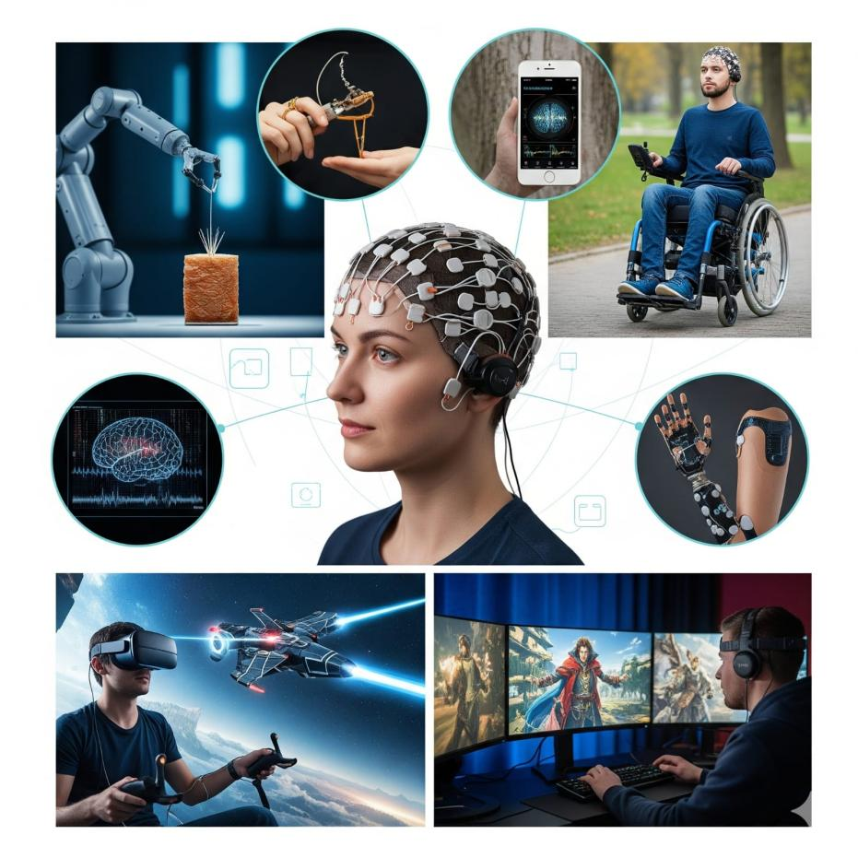

Figure7.1:Applications of Non-Invasive Brain–Computer Interfaces Illustration

showing diverse real-world uses of BCIs—from robotic arm control and smart-device

operation to wheelchair navigation, virtual-reality gaming, immersive entertainment,

and neurofeedback training—highlighting the technology’s broad potential in healthcare,

rehabilitation, and consumer interaction.

7.6 Summary
From life-changing communication aids to cutting-edge entertainment, non-invasive BCIs demonstrate remarkable flexibility. Continuous improvements in hardware, signal processing, and machine learning are expanding these applications beyond specialized clinics into everyday life, making brain-controlled interaction increasingly practical and accessible.

CHAPTER 8

CHALLENGES & FUTURE SCOPE
While non-invasive Brain–Computer Interfaces (BCIs) have achieved significant progress, several obstacles still limit their widespread adoption. This chapter summarizes the key technical, human, and ethical challenges and outlines promising directions for future research and development.

8.1 Technical Challenges
Low Signal-to-Noise Ratio (SNR)
Electrical potentials recorded from the scalp are extremely small and susceptible to interference from muscle activity, eye movements, and environmental noise. This limits the information transfer rate and can degrade performance during mobile or real-world tasks.
Limited Information Transfer Rate
Even with optimized algorithms, non-invasive BCIs generally transmit fewer bits per second than invasive counterparts. Achieving high-speed control of complex devices remains a critical research goal.
Signal Variability and Drift
EEG signals vary across sessions, users, and even time of day, necessitating frequent recalibration. Addressing inter- and intra-subject variability through adaptive or transfer-learning methods is an active area of study.
User Training Requirements
Many BCI paradigms require extensive training for users to generate consistent neural patterns, contributing to “BCI illiteracy,” where some individuals cannot achieve adequate control despite practice.

8.2 Human and Ethical Considerations
User Comfort and Fatigue
Wearing EEG caps for long periods can be uncomfortable, and extended sessions may cause mental fatigue that reduces accuracy.
Privacy and Data Security
Brain signals contain sensitive cognitive information. Protecting neural data against misuse or unauthorized access is paramount.
Informed Consent and Acceptance
Ethical deployment demands transparency about data usage, system limitations, and potential risks. Public understanding and acceptance remain essential for consumer adoption.

8.3 Future Research Directions
Wearable, Low-Cost Hardware
The development of fully wireless, dry-electrode EEG headsets promises easier setup and everyday usability.
AI-Driven Adaptive Decoding
Deep learning combined with online adaptation and transfer learning aims to deliver calibration-free systems that maintain accuracy across users and environments.
Hybrid and Multimodal BCIs
Integrating multiple signals (e.g., EEG with fNIRS or electromyography) can increase robustness and control dimensionality.
Integration with AR/VR and IoT
Merging BCI control with augmented reality, virtual reality, and smart-home platforms will enable natural, immersive interactions.

Cognitive and Emotional Monitoring
Next-generation BCIs will move beyond motor control to track mental states such as attention, stress, and emotion, opening opportunities in healthcare, education, and workplace safety.

8.4 Summary
Non-invasive BCIs are poised to transform healthcare, rehabilitation, and human–machine interaction. Overcoming technical hurdles—particularly low SNR and calibration demands—alongside ensuring privacy and ethical use, will be key to their success. With ongoing advancements in wearable hardware, adaptive AI algorithms, and multimodal integration, BCIs are expected to evolve from specialized research tools into mainstream consumer technology, seamlessly blending human cognition with digital systems.

CHAPTER 9

USER TRAINING STRATEGIES IN NON-INVASIVE BCIs

9.1 Overview and Importance
Non-invasive Brain–Computer Interfaces (BCIs) depend not only on sophisticated sensors and decoding algorithms but also on the ability of users to intentionally produce consistent and distinguishable brain signals. Although modern machine-learning techniques can adapt to individual differences, the quality and stability of the neural patterns generated by the user often determine whether the interface performs reliably. Natural brain activity is inherently variable, affected by factors such as attention level, fatigue, and emotional state. As a result, many first-time users experience difficulty achieving the signal consistency needed for high-accuracy control, a challenge often referred to as BCI illiteracy. Over the last decade, researchers have demonstrated that structured and carefully designed training programs can dramatically improve a person’s ability to communicate effectively with a BCI, making user training a critical component of successful deployment.
Training serves several important purposes. It introduces users to the specific mental strategies—such as kinesthetic motor imagery or visual attention to flickering stimuli—that produce recognizable patterns like event-related desynchronization or P300 potentials. At the same time, initial sessions provide the system with essential calibration data, allowing spatial filters and classifiers to be tuned to the individual’s unique neural signatures. Equally important, early training builds the user’s confidence and comfort, which is vital for extended sessions and for real-world tasks that require sustained concentration.

9.2 Training Procedures and Feedback
The typical process begins with a set of calibration sessions in which participants perform simple, well-defined mental tasks while their brain activity is recorded. For example, in a motor-imagery paradigm a user might repeatedly imagine moving the left or right hand,

while visual cues indicate which movement to simulate. In a P300 speller setup, the user silently counts when a target letter flashes within a matrix of characters. These initial recordings capture the baseline features that will later be used by the decoding algorithms. Once calibration is complete, practice sessions gradually introduce more complex interactions. A participant may first attempt to move a cursor horizontally, then progress to controlling a two-dimensional cursor or selecting letters to form words. Early sessions often show only moderate accuracy, but repetition combined with immediate feedback steadily strengthens the ability to reproduce the required brain states.
Real-time feedback is one of the most powerful tools in user training. Many systems display a moving bar or an animated object that responds instantly to the strength and correctness of the detected signal, enabling users to recognize which mental actions produce the desired effect. Auditory cues such as tones or spoken prompts, and even subtle tactile vibrations, provide additional reinforcement. To keep motivation high and reduce mental fatigue, some research groups employ game-like tasks or immersive virtual-reality environments where successful mental commands might make a character jump, a drone fly forward, or a virtual object light up. These engaging settings turn repetitive practice into an interactive experience and help maintain the intense focus required for optimal signal generation.

9.3 Research Outcomes and Future Directions
Studies consistently show that structured practice yields measurable gains. In many motor-imagery BCIs, classification accuracy improves from about 60 % in the first session to more than 80 % after just two or three weeks of regular training. Response times shorten, and the information-transfer rate—measured in bits per minute—increases significantly. Researchers are now exploring adaptive training methods in which machine-learning algorithms monitor ongoing performance and automatically adjust task difficulty or feedback sensitivity. Such adaptive systems prevent boredom when the task is too easy and reduce frustration when it is too difficult, keeping the user in an optimal learning zone.

Looking toward the future, user training is expected to become even more personalized and efficient. Lightweight dry-electrode EEG headsets already allow individuals to practice at home without lengthy setup, and cloud-based platforms can deliver tailored coaching while analyzing performance trends over weeks or months. Virtual-reality practice environments are being tested to provide fully immersive 3-D feedback, strengthening the link between mental intention and external action. Researchers are also investigating methods to identify the most responsive mental tasks for each user before training begins, further reducing the time required to reach high levels of control.

9.4 Summary
Systematic user training transforms a non-invasive BCI from an experimental technology into a practical communication and control tool. By helping individuals learn to generate stable neural patterns while allowing the system to adapt to those patterns, structured practice bridges the gap between human cognition and machine decoding. As training techniques become more adaptive, engaging, and accessible, BCIs will become easier to master and more widely adopted, extending their benefits from specialized laboratories to clinics, homes, and everyday consumer applications.

CHAPTER 10

CONCLUSION
Non-invasive Brain–Computer Interfaces (BCIs) have progressed from experimental systems into practical tools for communication, rehabilitation, and human–machine interaction. By safely capturing brain activity with external sensors—most prominently electroencephalography (EEG)—and decoding it through advanced signal-processing and machine-learning methods, BCIs now enable users to control devices such as robotic arms, wheelchairs, and smart-home technologies without muscular movement.
This report has reviewed the full BCI pipeline: signal acquisition, preprocessing, feature extraction, and decoding algorithms; explored major non-invasive signals including motor imagery, P300, and SSVEP; and surveyed diverse applications ranging from clinical rehabilitation to entertainment and industrial settings. Open-source toolboxes and deep-learning approaches are accelerating innovation, while hybrid paradigms are increasing robustness and control dimensionality.
Despite these achievements, challenges remain: low signal-to-noise ratio, limited information-transfer rates, inter-subject variability, and ethical concerns surrounding data privacy and user consent. Addressing these issues will require advances in wearable hardware, adaptive AI-driven decoding, and stronger privacy safeguards.
Looking ahead, the integration of BCIs with augmented/virtual reality, Internet of Things, and consumer electronics promises seamless everyday interaction between mind and machine. With continued interdisciplinary research, non-invasive BCIs are poised to become reliable, affordable, and ubiquitous—empowering individuals with disabilities and enhancing human capabilities for the broader population.

REFERENCES

[1] L. F. Nicolas-Alonso and J. Gomez-Gil, “Brain Computer Interfaces, a Review,” Sensors, vol. 12, no. 2, pp. 1211–1279, 2012.
[2] R. Abiri, S. Borhani, E. W. Sellers, Y. Jiang, and X. Zhao, “A Comprehensive Review of EEG-Based Brain–Computer Interface Paradigms,” Journal of Neural Engineering, vol. 16, no. 1, 2019.
[3] M. Ahn and S. C. Jun, “Performance Variation in Motor Imagery Brain–Computer Interface: A Review,” Frontiers in Human Neuroscience, vol. 9, 2015.
[4] J. R. Wolpaw, N. Birbaumer, D. J. McFarland, G. Pfurtscheller, and T. M. Vaughan, “Brain–Computer Interfaces for Communication and Control,” Clinical Neurophysiology, vol. 113, no. 6, pp. 767–791, 2002.
[5] G. Schalk et al., “BCI2000: A General-Purpose Brain–Computer Interface (BCI) System,” IEEE Transactions on Biomedical Engineering, vol. 51, no. 6, pp. 1034–1043, 2004.
[6] F. Lotte et al., “A Review of Classification Algorithms for EEG-Based Brain–Computer Interfaces: A 10 Year Update,” Journal of Neural Engineering, vol. 15, no. 3, 2018.
[7] P. Guger et al., “State of the Art and Trends in Non-Invasive Brain–Computer Interface,” IEEE Access, vol. 9, pp. 112874–112890, 2021.
[8] BCI Toolboxes Documentation: OpenViBE, EEGLAB, MNE-Python, and FieldTrip (official project websites, accessed 2025).
[9] J. R. Wolpaw and E. W. Wolpaw, Brain–Computer Interfaces: Principles and Practice. Oxford University Press, 2012.
[10] M. A. Lebedev and M. A. L. Nicolelis, “Brain–machine interfaces: Past, present and future,” Trends in Neurosciences, vol. 29, no. 9, pp. 536–546, 2006.
[11] N. Birbaumer and L. G. Cohen, “Brain–computer interfaces: Communication and restoration of movement in paralysis,” The Journal of Physiology, vol. 579, no. 3, pp. 621–636, 2007.
[12] J. J. Shih, D. J. Krusienski, and J. R. Wolpaw, “Brain–Computer Interfaces in Medicine,” Mayo Clinic Proceedings, vol. 87, no. 3, pp. 268–279, 2012.

[13] U. Chaudhary, N. Birbaumer, and A. Ramos-Murguialday, “Brain–Computer Interfaces for Communication and Rehabilitation,” Nature Reviews Neurology, vol. 12, no. 9, pp. 513–525, 2016.
[14] B. He et al., “Noninvasive Brain–Computer Interfaces Based on Electrophysiology and Metabolism: A Review,” IEEE Reviews in Biomedical Engineering, vol. 13, pp. 219–232, 2020.
[15] L. R. Hochberg et al., “Reach and Grasp by People with Tetraplegia Using a Neurally Controlled Robotic Arm,” Nature, vol. 485, pp. 372–375, 2012.
[16] M. J. Vansteensel et al., “Fully Implanted Brain–Computer Interface in a Locked-In Patient with ALS,” New England Journal of Medicine, vol. 375, no. 21, pp. 2060–2066, 2016.
[17] J. J. Daly and J. R. Wolpaw, “Brain–Computer Interfaces in Neurological Rehabilitation,” The Lancet Neurology, vol. 7, no. 11, pp. 1032–1043, 2008.
[18] S. Waldert, “Invasive vs. Non-Invasive Neuronal Signals for Brain–Machine Interfaces: Will One Prevail?” Frontiers in Neuroscience, vol. 10, 295, 2016.
[19] S. J. Bensmaia and L. E. Miller, “Restoring Sensorimotor Function through Intracortical Interfaces: Progress and Looming Challenges,” Nature Reviews Neuroscience, vol. 15, no. 5, pp. 313–325, 2014.
[20] A. L. Benabid et al., “An Exoskeleton Controlled by an Epidural Wireless Brain–Computer Interface in a Tetraplegic Patient: A Proof-of-Concept Demonstration,” The Lancet Neurology, vol. 18, no. 12, pp. 1112–1122, 2019

